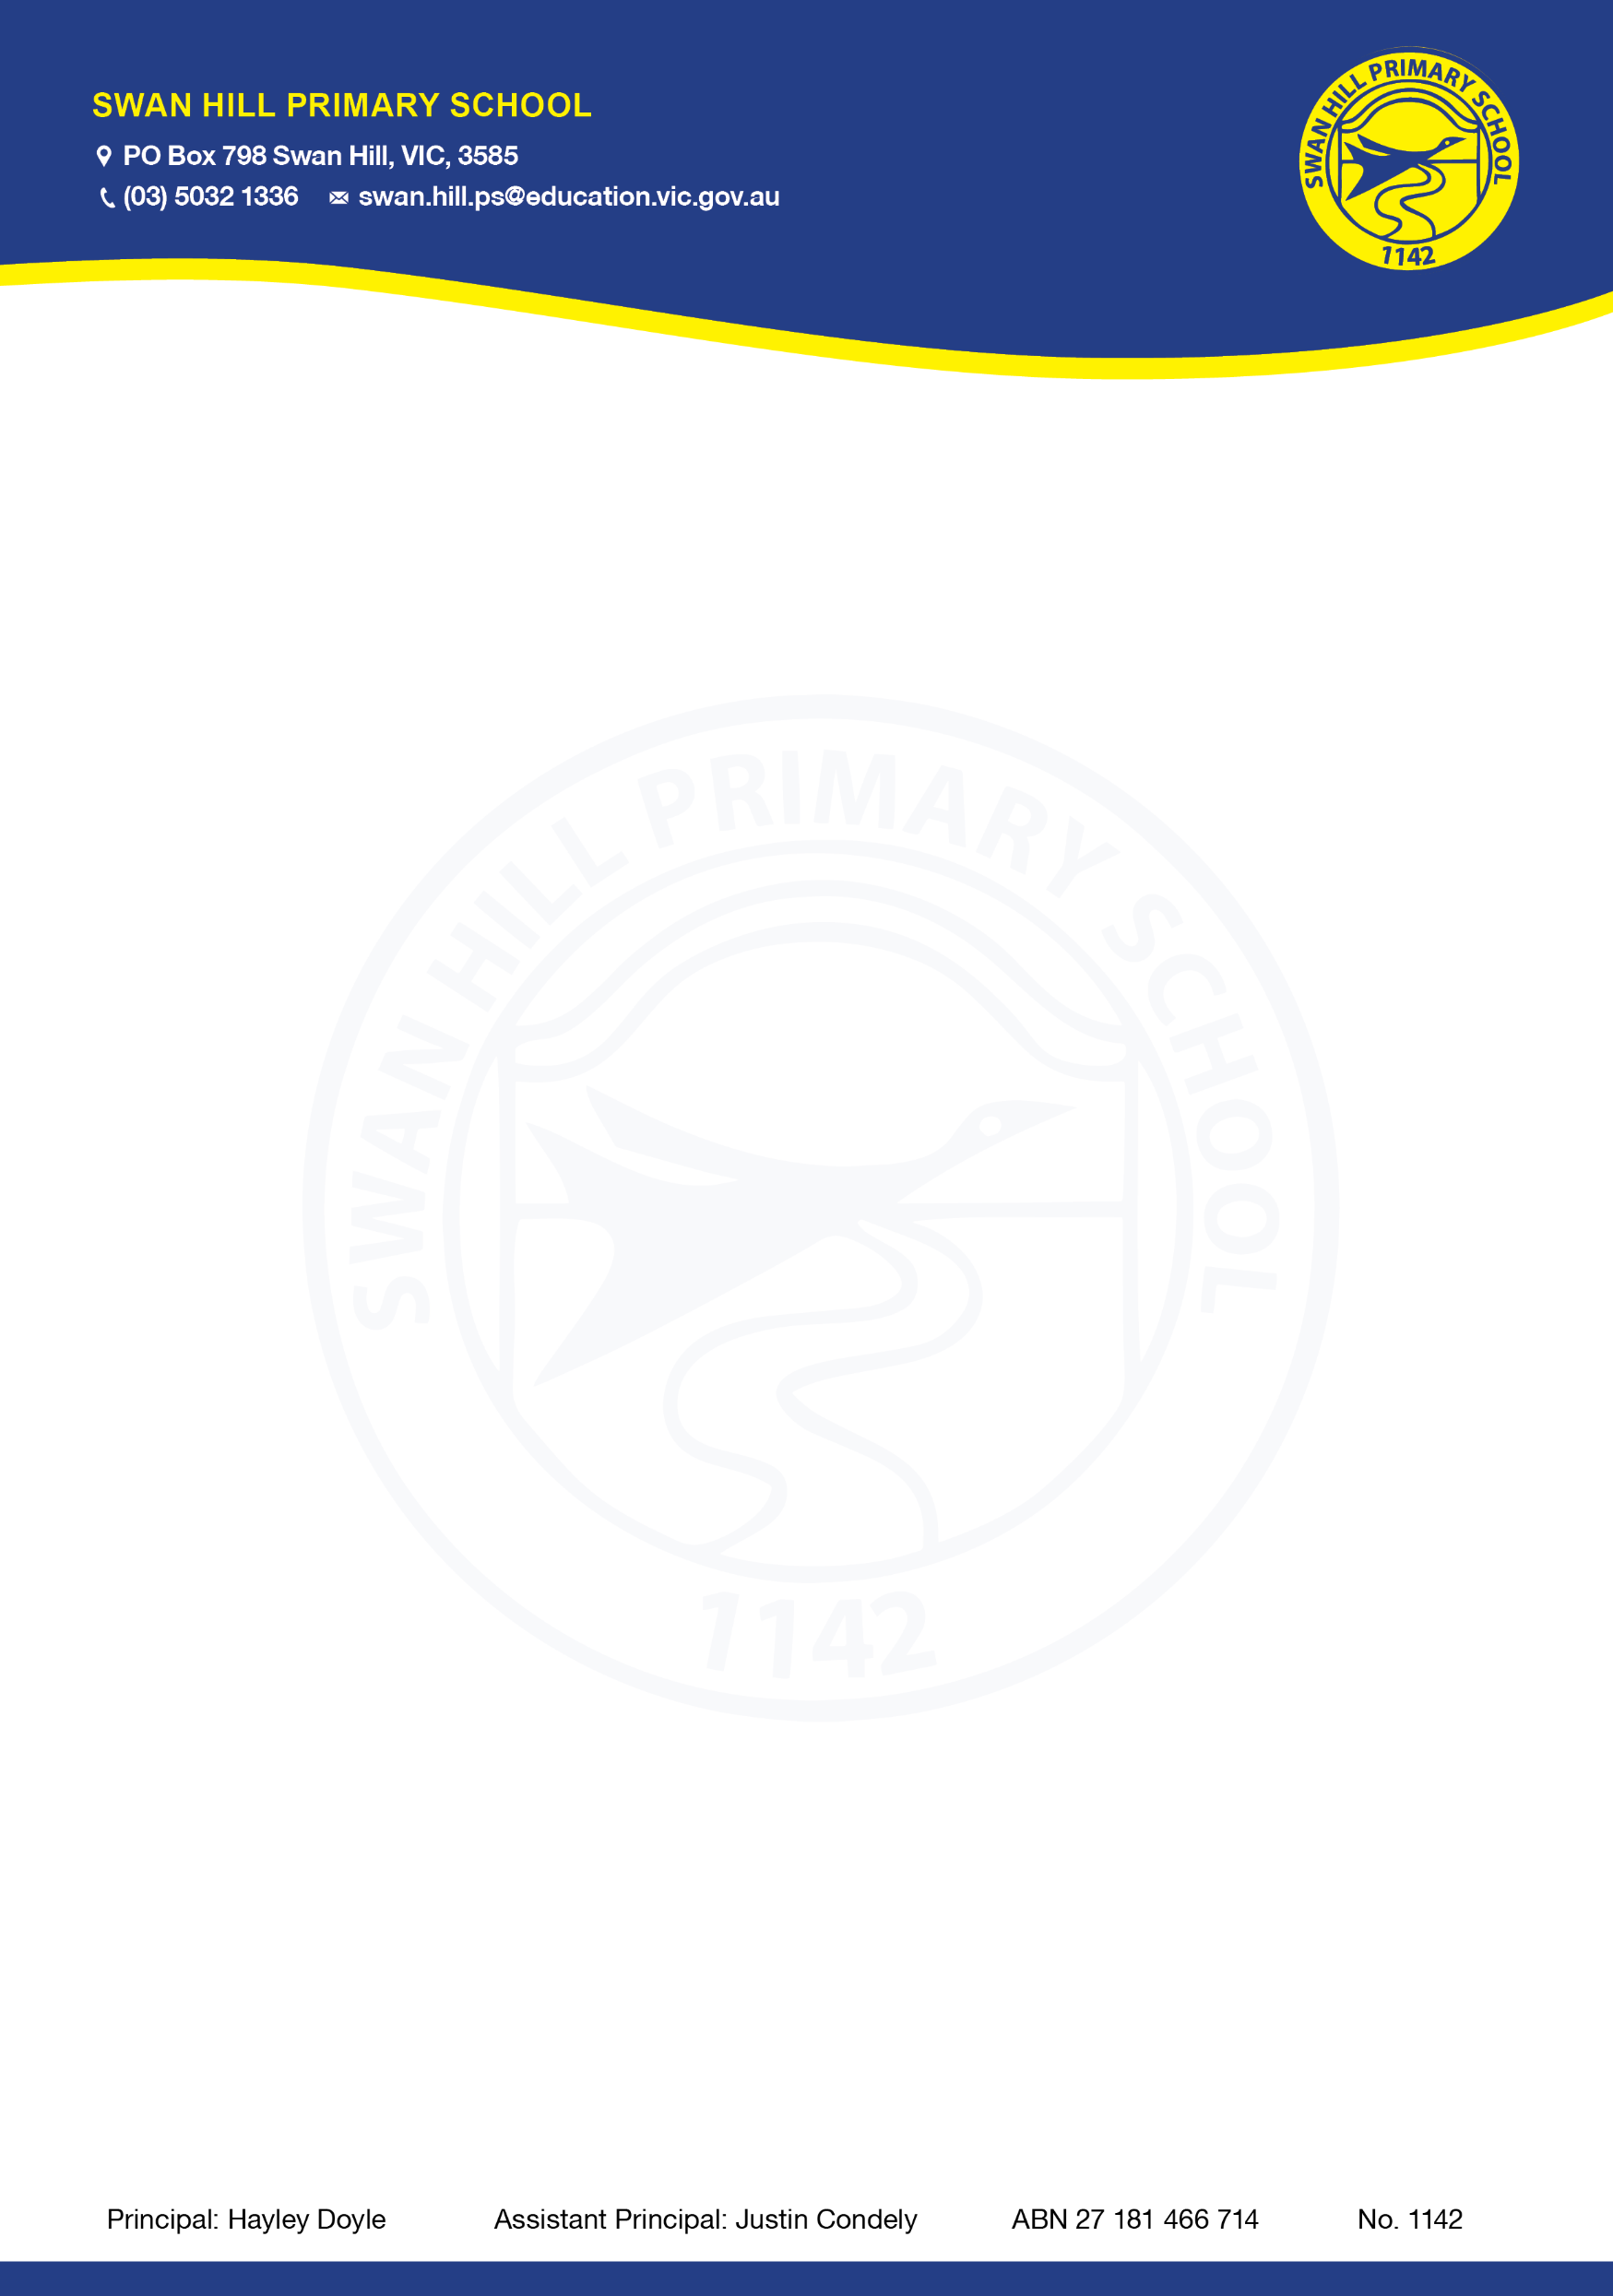

COMPLAINTS POLICY
Purpose
The purpose of this policy is to:
- provide an outline of the complaints process at Swan Hill Primary School so that students, parents and members of the community are informed of how they can raise complaints or concerns about issues arising at our school.
- ensure that all complaints and concerns regarding Swan Hill Primary School are managed in a timely, effective, fair and respectful manner.
Scope

This policy relates to complaints brought by students, parents, carers, or members of our school community and applies to all matters relating to our school.

In some limited instances, we may need to refer a complainant to another policy or area if there are different processes in place to the manage the issue including:
- Complaints and concerns relating to fraud and corruption will be managed in accordance with the department’s Fraud and Corruption Policy
- Criminal matters will be referred to Victoria Police
- Legal claims will be referred to the Department of Education’s Legal Division
- Complaints and concerns relating to child abuse will be managed in accordance with our Child Safety Responding and Reporting Obligations Policy and Procedures.
Policy
Swan Hill Primary School welcomes feedback, both positive and negative, and is committed to continuous improvement. We value open communication with our families and are committed to understanding complaints and addressing them appropriately. We recognise that the complaints process provides an important opportunity for reflection and learning.
We value and encourage open and positive relationships with our school community. We understand that it is in the best interests of students for there to be a trusting relationship between families and our school.
When addressing a complaint, it is expected that all parties will:
- be considerate of each other’s views and respect each other’s role
- be focused on resolution of the complaint, with the interests of the student involved at the centre
- act in good faith and cooperation
- behave with respect and courtesy
- respect the privacy and confidentiality of those involved, as appropriate
- operate within and seek reasonable resolutions that comply with any applicable legislation and Department policy.
- recognise that schools and the Department may be subject to legal constraints on their ability to act or disclose information in some circumstances.

COMPLAINTS AND CONCERNS PROCESS FOR STUDENTS
Swan Hill Primary School acknowledges that issues or concerns can cause stress or worry for students and impact their wellbeing and learning. Swan Hill Primary School encourages our students to raise issues or concerns as they arise, so that we can work together to resolve them.
Students with a concern or complaint can raise them with a trusted adult at school, for example, with your classroom teacher, Sub-School Leaders, Wellbeing staff, Koorie Education Support Officers, Multicultural Education Aides or Education Support staff. This person will take your concern or complaint seriously and will explain to you what steps we can take to try to resolve the issue and support you.
You can also ask your parent, carer or another trusted adult outside of the school, to talk to us about the issue instead. Information about our parent/carer complaints and concerns process is outlined further below. The parent/carer process also applies to students who are mature minors, refer to: Mature Minors and Decision Making.
Other ways you can raise a concern or complaint with us include:
- talking to a member of the Junior School Council or Student Leaders about your concern and any suggestions you have for resolving it
- participating in our Attitudes to School Survey (for Grades 4-6)
Further information and resources to support students to raise issues or concerns are available at:
- Report Racism Hotline (call 1800 722 476) – this hotline enables students to report concerns relating to racism or religious discrimination
- Reach Out
- Headspace
- Kids Helpline (call 1800 55 1800)
- Victorian Aboriginal Education Association (VAEAI)

Complaints and concerns process for parents, carers and community members

Preparation for raising a concern or complaint
Swan Hill Primary School encourages parents, carers or members of the community who may wish to submit a complaint to:
- carefully consider the issues you would like to discuss
- remember you may not have all the facts relating to the issues that you want to raise
- think about how the matter could be resolved
- be informed by checking the policies and guidelines set by the Department and Swan Hill Primary School (see “Further Information and Resources” section below).
Support person
You are welcome to have a support person to assist you in raising a complaint or concern with our school. Please advise us if you wish to have a support person to assist you, and provide their name, contact details, and their relationship to you.
Raising a concern
Swan Hill Primary School is always happy to discuss with parents/carers and community members any concerns that they may have. Concerns in the first instance should be directed to your child’s teacher, Sub-School Leader, Assistant Principal or Principal. Where possible, school staff will work with you to ensure that your concerns are appropriately addressed.
Making a complaint
Where concerns cannot be resolved in this way, parents or community members may wish to make a formal complaint to the Principal or Assistant Principal. All formal complaints should be directed to a member of the school’s leadership team.
If you would like to make a formal complaint, in most cases, depending on the nature of the complaint raised, our school will first seek to understand the issues and will then convene a resolution meeting with the aim of resolving the complaint together. The following process will apply:
- Complaint received: Please either email, telephone or arrange a meeting through the front office with the Assistant Principal or Principal, to outline your complaint so that we can fully understand what the issues are. We can discuss your complaint in a way that is convenient for you, whether in writing, in person or over the phone.

- Information gathering: Depending on the issues raised in the complaint, the Principal, Assistant Principal or nominee may need to gather further information to properly understand the situation. This process may also involve speaking to others to obtain details about the situation or the concerns raised.

- Response: Where possible, a resolution meeting will be arranged with the Assistant Principal or Principal to discuss the complaint with the objective of reaching a resolution satisfactory to all parties. If after the resolution meeting we are unable to resolve the complaint together, we will work with you to produce a written summary of the complaint in the event you would like to take further action about it. In some circumstances, the Principal may determine that a resolution meeting would not be appropriate. In this situation, a response to the complaint will be provided in writing.

- Timelines: Swan Hill Primary School will acknowledge receipt of your complaint as soon as possible (usually within two school days) and will seek to resolve complaints in a timely manner. Depending on the complexity of the complaint, Swan Hill Primary School may need some time to gather enough information to fully understand the circumstances of your complaint. We will endeavour to complete any necessary information gathering and hold a resolution meeting where appropriate within 10 working days of the complaint being raised. In situations where further time is required, Swan Hill Primary School will consult with you and discuss any interim solutions to the dispute that can be put in place.

Please note that unreasonable conduct (e.g. vexatious complaints) may need to be managed differently to the procedures in this policy.

Resolution
Where appropriate, Swan Hill Primary School may seek to resolve a complaint by:
- an apology or expression of regret
- a change of decision
- a change of policy, procedure or practice
- A restorative practice conversation with the involved parties, facilitated by a member of leadership
- offering the opportunity for student counselling or other support
- other actions consistent with school values that are intended to support the student, parent and school relationship, engagement, and participation in the school community.
In some circumstances, Swan Hill Primary School may also ask you to attend a meeting with an independent third party, or participate in a mediation with an accredited mediator to assist in the resolution of the dispute.

Escalation
If you are not satisfied that your complaint has been resolved by the school, or if your complaint is about the Principal and you do not want to raise it directly with them, then the complaint should be referred to the Southern Mallee Network by contacting +61 3 4433 7668.
Swan Hill Primary School may also refer a complaint to the Southern Mallee Network SEIL if we believe that we have done all we can to address the complaint.
For more information about the Department’s parent complaints process, including the role of the Regional Office, please see: Raise a complaint or concern about your school.
Record keeping and other requirements
To meet Department and legal requirements, our school must keep written records of:
- Serious, substantial or unusual complaints
- Complaints relating to the Child Information Sharing Scheme and Family Violence Information Sharing Scheme, to meet regulatory requirements - refer to Child and Family Violence Information Sharing Schemes for further information
Our school also follows Department policy to ensure that record-keeping, reporting, privacy and employment law obligations are met when responding to complaints or concerns.
COMMUNICATION
This policy will be communicated to our school community in the following ways:
- Available publicly on school website
- Included in staff induction processes
- Links to the policy are in the staff handbook/manual
- Annual reference in school newsletter
- Hard copy available from school administration upon request

FURTHER INFORMATION AND RESOURCES

The Department’s Policy and Advisory Library (PAL):
- Complaints - Parents

The Department’s parents’ website:
- Raise a complaint or concern about your school
- Report racism or religious discrimination in schools

Policy review and approval
Policy last reviewed | August 2023
Consultation | Consultation period with Swan Hill Primary School Staff occurred from August 21st 2023 for 2 weeks.
Approved by | Principal – Hayley Doyle
Next scheduled review date | August 2025 – noting that the mandatory review cycle for this policy 2 years

