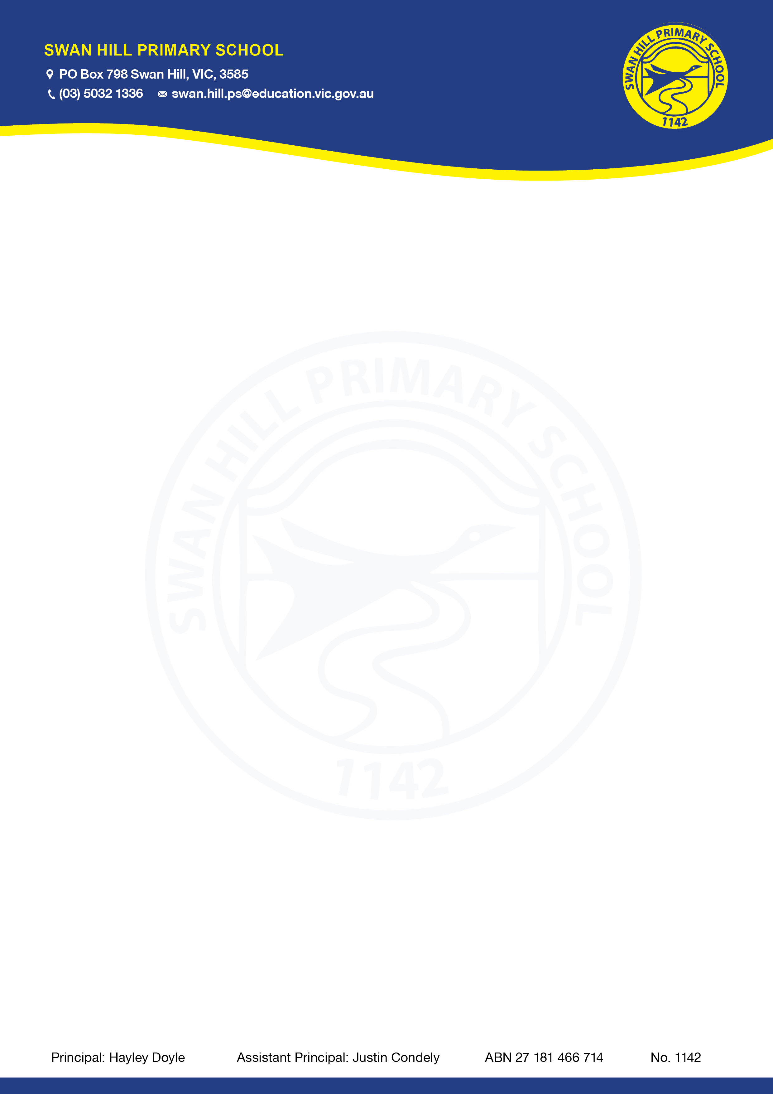

ANAPHYLAXIS POLICY

Purpose
To explain to Swan Hill Primary School parents, carers, staff and students the processes and procedures in place to support students diagnosed as being at risk of suffering from anaphylaxis. This policy also ensures that Swan Hill Primary School is compliant with Ministerial Order 706 and the Department’s guidelines for anaphylaxis management.

Scope
This policy applies to:
- all staff, including casual relief staff and volunteers
- all students who have been diagnosed with anaphylaxis, or who may require emergency treatment for an anaphylactic reaction, and their parents and carers.

Policy
School Statement
Swan Hill Primary School will fully comply with Ministerial Order 706 and the associated guidelines published by the Department of Education and Training.

Anaphylaxis
Anaphylaxis is a severe allergic reaction that occurs after exposure to an allergen. The most common allergens for school-aged children are nuts, eggs, cow’s milk, fish, shellfish, wheat, soy, sesame, latex, certain insect stings and medication.
Symptoms
Signs and symptoms of a mild to moderate allergic reaction can include:
- swelling of the lips, face and eyes
- hives or welts
- tingling in the mouth.
Signs and symptoms of anaphylaxis, a severe allergic reaction, can include:
- difficult/noisy breathing
- swelling of tongue
- difficulty talking and/or hoarse voice
- wheeze or persistent cough
- persistent dizziness or collapse
- student appears pale or floppy
- abdominal pain and/or vomiting.
Symptoms usually develop within ten minutes and up to two hours after exposure to an allergen, but can appear within a few minutes.
Treatment
Adrenaline given as an injection into the muscle of the outer mid-thigh is the first aid treatment for anaphylaxis.
Individuals diagnosed as being at risk of anaphylaxis are prescribed an adrenaline autoinjector for use in an emergency. These adrenaline autoinjectors are designed so that anyone can use them in an emergency.

Individual Anaphylaxis Management Plans
All students at Swan Hill Primary School who are diagnosed by a medical practitioner as being at risk of suffering from an anaphylactic reaction must have an Individual Anaphylaxis Management Plan. When notified of an anaphylaxis diagnosis, the Principal of Swan Hill Primary School is responsible for developing a plan in consultation with the student’s parents/carers.
Where necessary, an Individual Anaphylaxis Management Plan will be in place as soon as practicable after a student enrols at Swan Hill Primary School and where possible, before the student’s first day.
Parents and carers must:
- obtain an ASCIA Action Plan for Anaphylaxis from the student’s medical practitioner and provide a copy to the school as soon as practicable
- immediately inform the school in writing if there is a relevant change in the student’s medical condition and obtain an updated ASCIA Action Plan for Anaphylaxis
- provide an up-to-date photo of the student for the ASCIA Action Plan for Anaphylaxis when that Plan is provided to the school and each time it is reviewed
- provide the school with a current adrenaline autoinjector for the student that has not expired;
- participate in annual reviews of the student’s Plan.
Each student’s Individual Anaphylaxis Management Plan must include:
- information about the student’s medical condition that relates to allergies and the potential for anaphylactic reaction, including the type of allergies the student has
- information about the signs or symptoms the student might exhibit in the event of an allergic reaction based on a written diagnosis from a medical practitioner
- strategies to minimise the risk of exposure to known allergens while the student is under the care or supervision of school staff, including in the school yard, at camps and excursions, or at special events conducted, organised or attended by the school
- the name of the person(s) responsible for implementing the risk minimisation strategies, which have been identified in the Plan
- information about where the student's medication will be stored
- the student's emergency contact details
- an up-to-date ASCIA Action Plan for Anaphylaxis completed by the student’s medical practitioner.
Review and updates to Individual Anaphylaxis Management Plans
A student’s Individual Anaphylaxis Management Plan will be reviewed and updated on an annual basis in consultation with the student’s parents/carers. The plan will also be reviewed and, where necessary, updated in the following circumstances:
- as soon as practicable after the student has an anaphylactic reaction at school
- if the student’s medical condition, insofar as it relates to allergy and the potential for anaphylactic reaction, changes
- when the student is participating in an off-site activity, including camps and excursions, or at special events including fetes and concerts.
Our school may also consider updating a student’s Individual Anaphylaxis Management Plan if there is an identified and significant increase in the student’s potential risk of exposure to allergens at school.

Location of plans and adrenaline autoinjectors
A copy of each student’s Individual Anaphylaxis Management Plan will be stored with their ASCIA Action Plan for Anaphylaxis at the General Office in 1st medication drawer, together with the student’s adrenaline autoinjector. Adrenaline autoinjectors must be labelled with the student’s name.

Risk Minimisation Strategies
To reduce the risk of a student suffering from an anaphylactic reaction at Swan Hill Primary School, we have put in place the following strategies:
- Swan Hill Primary School is an Allergy Aware School
- It is asked that all students clearly label food and drink containers with names.
- staff and students are regularly reminded to wash their hands after eating;
- students are discouraged from sharing food
- garbage bins at school are to remain covered with lids to reduce the risk of attracting insects
- Teachers are aware of hidden allegens in Specialist classes such as Art and Science where food boxes may be used.
- gloves must be worn when picking up papers or rubbish in the playground;
- school canteen staff are trained in appropriate food handling to reduce the risk of cross-contamination
- year groups will be informed of allergens that must be avoided in advance of class parties, events or birthdays
- Some materials (such as play dough) can contain food allergens - Check that nut oils have not been used in the manufacturing process.
- a general use adrenaline autoinjector will be stored at the school office.
- Planning for off-site activities will include risk minimisation strategies for students at risk of anaphylaxis including supervision requirements, appropriate number of trained staff, emergency response procedures and other risk controls appropriate to the activity and students attending.

Adrenaline autoinjectors for general use
Swan Hill Primary School will maintain a supply of adrenaline autoinjectors for general use, as a back-up to those provided by parents and carers for specific students, and also for students who may suffer from a first time reaction at school.
Adrenaline autoinjectors for general use will be stored at the office in the medical drawer and labelled “general use”.
The Principal is responsible for arranging the purchase of adrenaline autoinjectors for general use, and will consider:
- the number of students enrolled at Swan Hill Primary School at risk of anaphylaxis
- the accessibility of adrenaline autoinjectors supplied by parents
- the availability of a sufficient supply of autoinjectors for general use in different locations at the school, as well as at camps, excursions and events
- the limited life span of adrenaline autoinjectors, and the need for general use adrenaline autoinjectors to be replaced when used or prior to expiry
- the weight of the students at risk of anaphylaxis to determine the correct dosage of adrenaline autoinjector/s to purchase.

Emergency Response
In the event of an anaphylactic reaction, the emergency response procedures in this policy must be followed, together with the school’s general first aid procedures, emergency response procedures and the student’s Individual Anaphylaxis Management Plan.
A complete and up-to-date list of students identified as being at risk of anaphylaxis is maintained by Lee Cox and stored at [Main Office in Medical drawer For camps, excursions and special events, a designated staff member will be responsible for maintaining a list of students at risk of anaphylaxis attending the special event, together with their Individual Anaphylaxis Management Plans and adrenaline autoinjectors, where appropriate.
If a student experiences an anaphylactic reaction at school or during a school activity, school staff must:
Step | Action
- Lay the person flat
- Do not allow them to stand or walk
- If breathing is difficult, allow them to sit
- Be calm and reassuring
- Do not leave them alone
- Seek assistance from another staff member or reliable student to locate the student’s adrenaline auto injector or the school’s general use auto injector, and the student’s Individual Anaphylaxis Management Plan, stored in orange case with auto injector (in medial drawer in General Office.
- If the student’s plan is not immediately available, or they appear to be experiencing a first time reaction, follow steps 2 to 5
Administer an EpiPen or EpiPen Jr
- Remove from plastic container
- Form a fist around the EpiPen and pull off the blue safety release (cap)
- Place orange end against the student’s outer mid-thigh (with or without clothing)
- Push down hard until a click is heard or felt and hold in place for 3 seconds
- Remove EpiPen
- Note the time the EpiPen is administered
- Retain the used EpiPen to be handed to ambulance paramedics along with the time of administration

OR

Administer an Anapen® 500, Anapen® 300, or Anapen® Jr.
- Pull off the black needle shield
- Pull off grey safety cap (from the red button)
- Place needle end firmly against the student's outer mid-thigh at 90 degrees (with or without clothing)
- Press red button so it clicks and hold for 10 seconds
- Remove Anapen®
- Note the time the Anapen is administered
- Retain the used Anapen to be handed to ambulance paramedics along with the time of administration
 | Call an ambulance (000)
 | If there is no improvement or severe symptoms progress (as described in the ASCIA Action Plan for Anaphylaxis), further adrenaline doses may be administered every five minutes, if other adrenaline autoinjectors are available.
 | Contact the student’s emergency contacts.

If a student appears to be having a severe allergic reaction but has not been previously diagnosed with an allergy or being at risk of anaphylaxis, school staff should follow steps 2 – 5 as above.
Schools can use either the EpiPen® and Anapen® on any student suspected to be experiencing an anaphylactic reaction, regardless of the device prescribed in their ASCIA Action Plan.
Where possible, schools should consider using the correct dose of adrenaline autoinjector depending on the weight of the student. However, in an emergency if there is no other option available, any device should be administered to the student.

Communication Plan
This policy will be available on Swan Hill Primary School’s website so that parents and other members of the school community can easily access information about Swan Hill Primary School’s anaphylaxis management procedures. The parents and carers of students who are enrolled at Swan Hill Primary School and are identified as being at risk of anaphylaxis will also be provided with a copy of this policy.
The Principal is responsible for ensuring that all relevant staff, including casual relief staff, canteen staff and volunteers are aware of this policy and Swan Hill Primary School’s procedures for anaphylaxis management. Casual relief staff and volunteers who are responsible for the care and/or supervision of students who are identified as being at risk of anaphylaxis will also receive a verbal briefing on this policy, their role in responding to an anaphylactic reaction and where required, the identity of students at risk.
The Principal is also responsible for ensuring relevant staff are trained and briefed in anaphylaxis management, consistent with the Department’s Anaphylaxis Guidelines.

Staff training
The Principal will ensure that the following school staff are appropriately trained in anaphylaxis management:
- School staff who conduct classes attended by students who are at risk of anaphylaxis
- School staff who conduct specialist classes, all canteen staff, admin staff, first aiders and any other member of school staff as required by the Principal based on a risk assessment.
Staff who are required to undertake training must have completed:
- an approved face-to-face anaphylaxis management training course in the last three years, or
- an approved online anaphylaxis management training course in the last two years.
Swan Hill Primary School uses the following training course ASCIA eTraining course with 22579VIC, and 22578VIC.
Staff are also required to attend a briefing on anaphylaxis management and this policy at least twice per year (with the first briefing to be held at the beginning of the school year), facilitated by a staff member who has successfully completed an anaphylaxis management course within the last 2 years including School Anaphylaxis Supervisors Laura Butler and Belinda Free
Each briefing will address:
- this policy
- the causes, symptoms and treatment of anaphylaxis
- the identities of students with a medical condition that relates to allergies and the potential for anaphylactic reaction, and where their medication is located
- how to use an adrenaline autoinjector, including hands on practice with a trainer adrenaline autoinjector
- the school’s general first aid and emergency response procedures
- the location of, and access to, adrenaline autoinjectors that have been provided by parents or purchased by the school for general use.
When a new student enrols at Swan Hill Primary School who is at risk of anaphylaxis, the Principal will develop an interim plan in consultation with the student’s parents and ensure that appropriate staff are trained and briefed as soon as possible.
A record of staff training courses and briefings will be maintained through the school’s online Emergency Management Plan.
The Principal will ensure that while students at risk of anaphylaxis are under the care or supervision of the school outside of normal class activities, including in the school yard, at camps and excursions, or at special event days, there is a sufficient number of school staff present who have been trained in anaphylaxis management.

Further information and resources
- The Department’s Policy and Advisory Library (PAL):
  - Anaphylaxis
- Allergy & Anaphylaxis Australia
- ASCIA Guidelines: Schooling and childcare
- Royal Children’s Hospital: Allergy and immunology
POLICY REVIEW AND APPROVAL
Policy last reviewed | Feb 2023
Approved by | Principal
Next scheduled review date | Feb 2024

The Principal will complete the Department’s Annual Risk Management Checklist for anaphylaxis management to assist with the evaluation and review of this policy and the support provided to students at risk of anaphylaxis.

